***Amazon Web Services (AWS) :-***

***Amazon’s cloud offering, popularly known as***[***AWS***](http://aws.amazon.com/)***is probably the biggest cloud computing company at this time. It is world leader in two of most popular forms of cloud computing Infrastructure as a Service (IaaS) and Platform as a Service (PaaS).***

***Google Compute Engine :-***

[***Google Compute Engine (GCE)***](https://cloud.google.com/products/compute-engine/)***They are very similar to Amazon’s AWS but in some respect they even beat them; Like Amazon, Google’s cloud infrastructure is built to support their own business mainly for Google Search, Gmail and other products.***

***CloudBees :-***

[***CloudBees***](http://www.cloudbees.com/)***is relatively new entrant in cloud computing space and focusing on Java Paas and Continuous delivery area. Unlike many other Platform as a Service vendors, CloudBees seems to be committed on Java, Grails and JRails. Apart from Platform as a Service, CloudBees offers continuous integration services through its Jenkins plugins and also has tie-ups with a number of ecosystem partners, e.g. New Relic for monitoring and PaperTrail for log sequencing. The Jenkins plugin is also used by Google App Engine.***

***Rackspace :-***

[***Rackspace***](http://www.rackspace.com/cloud/)***is another growing cloud computing company in Infrastructure as a Service (IaaS) and Platform as Service (Paas) space. Rackspace has played a significant role in developing and shaping OpenStack, the much talked about open source cloud software.***

***CloudSigma :-***

[***CloudSigma***](http://www.cloudsigma.com/)***is a company which thinks that the currently available public clouds are a lot more restrictive than it should be and it aims to facilitate a more flexible and collaborative relationship between public cloud providers and customers. They are not as big as Amazon AWS or Rackspace, market leaders of Infrastructure as a Service (IaaS) offering, but aims to provide an alternative close to customers. The utility, approach to IaaS to configure  CPU performance, RAM size, storage size will surely attract many more customers in the future.***

**Type Of Hypervisor**

*A hypervisor monitors the creation and running of virtual machines. It allows a large number of machines with different operating systems(CentOS,Fedora,OpenSUSE) to run on a single host machine.*

**A hypervisor is a software layer which provides the capability to run multiple virtual machines on the same physical host**. It generally falls into either one of the following two classifications  Type1 and Type2 hypervisors.  
Type1 hypervisors directly run on the physical hardware. They control the hardware as well as manage the virtual machines. Type1 are also termed bare metal hypervisors.

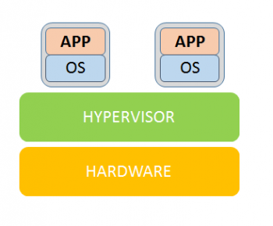  
Type2 hypervisors run as an application on an existing operating system (also known as the host operating system), which is installed on the bare metal. Here, there is an added complexity of the guest operating system calls needing to traverse via the host operating system stack before they reach the hardware.

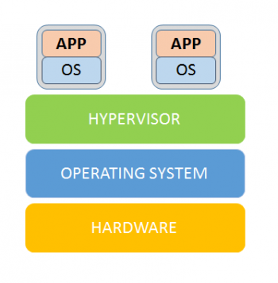

**Security of 5 Cloud Service Providers**

Rackspace Global Security Services, is responsible for setting objectives for information security management to preserve our commitment to our customers. This includes setting policies in the following areas:

**ASSET MANAGEMENT**

This area focuses on achieving and maintaining appropriate protection of Rackspace's critical infrastructure required for its service delivery.

**HUMAN RESOURCES SECURITY**

Controls to ensure that all Rackspace employees, contractors and third party users understand their responsibilities, and are suitable for the roles they are considered.

**PHYSICAL AND ENVIRONMENTAL SECURITY**

To prevent unauthorized physical access, damage, and interference to our organization's premises and information.

**ACCESS CONTROL**

Framework to ensure only approved users are granted access to appropriate systems and resources.

**INFORMATION SECURITY INCIDENT MANAGEMENT**

Policies and processes aimed at making sure information security events and weaknesses are communicated in a manner allowing timely corrective action.

At CloudSigma, we take security very serious. Since the very beginning, all our web app (the cloud control panel) and our API has been configured to accept SSL connections only.

 Google Compute Engine encrypts the persistent disks with [AES-128-CB](https://en.wikipedia.org/wiki/Advanced_Encryption_Standard), and this encryption is applied before the data leaves the virtual machine monitor and hits the disk. Encryption is always enabled and is transparent to Google Compute Engine users. The integrity of persistent disks is maintained via a [HMAC](https://en.wikipedia.org/wiki/HMAC) scheme.